**ASSIGNMENT 1**

**SCOs using HTML5**

**Assignment Objectives :**

* **HEADER/FOOTER tag** - All screens contain both tags.
* **DATA tag** - All question screens contain the tag for correct answer.
* **MARK tag -** Verbal question screen contains the tag and script for populating value on radio click.
* **VIDEO tag -** Video/Audio question screen contains the tag.
* **DATALIST tag -** Survey screen contains the tag to populate the City and Room Number dropdowns.
* **SUMMARY tag -** Score card screen contains the summary tag for scores in each section.
* **MATHML library -** Quant questions use this library for math questions to represent equations in correct format.

**Application :** <https://s3.amazonaws.com/cmpe280-assignment1/index.html>

**1. Login Screen**

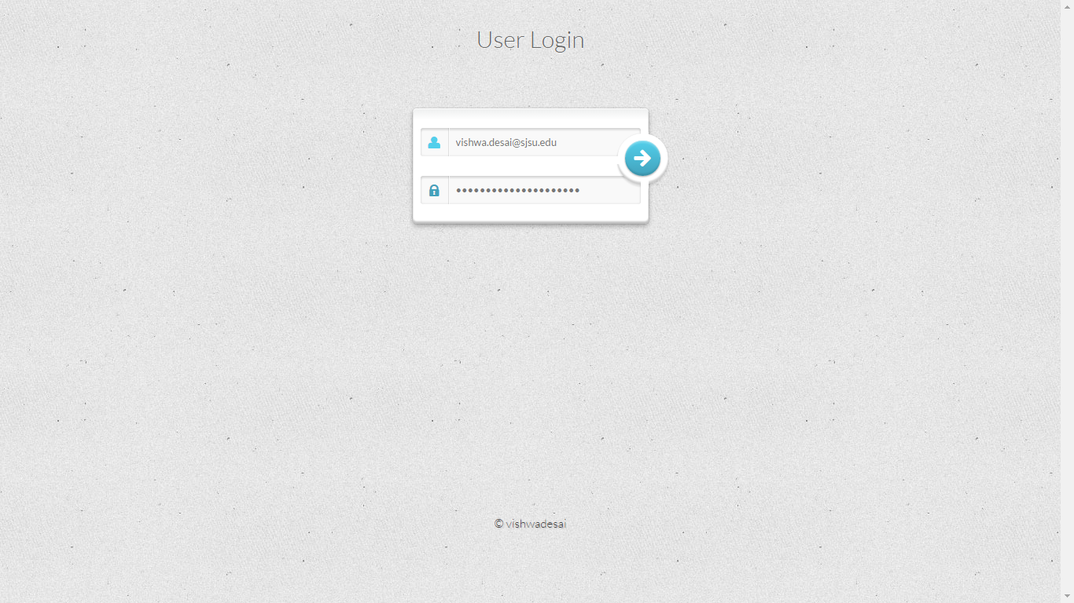

**2. Quant Question 1 ( MathML library)**

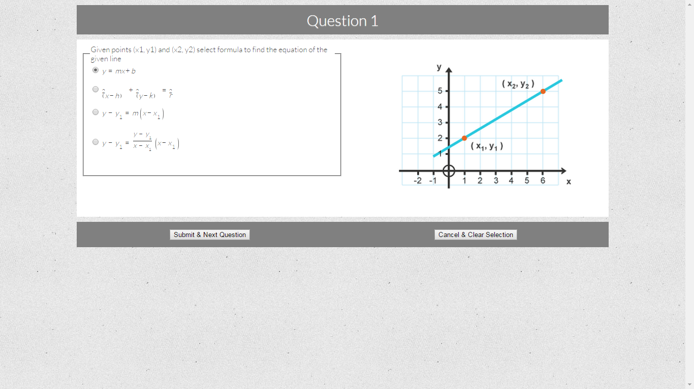

**3. Quant Question 2 ( MathML library)**

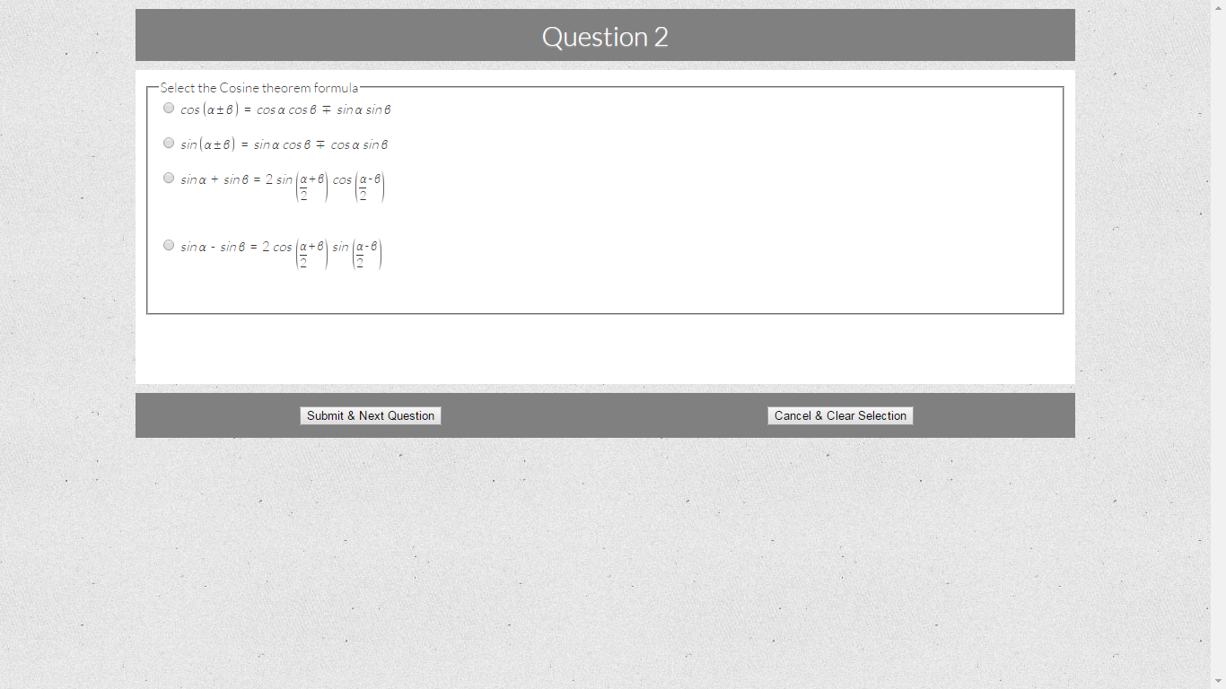

**4. English Question ( Mark tag)**

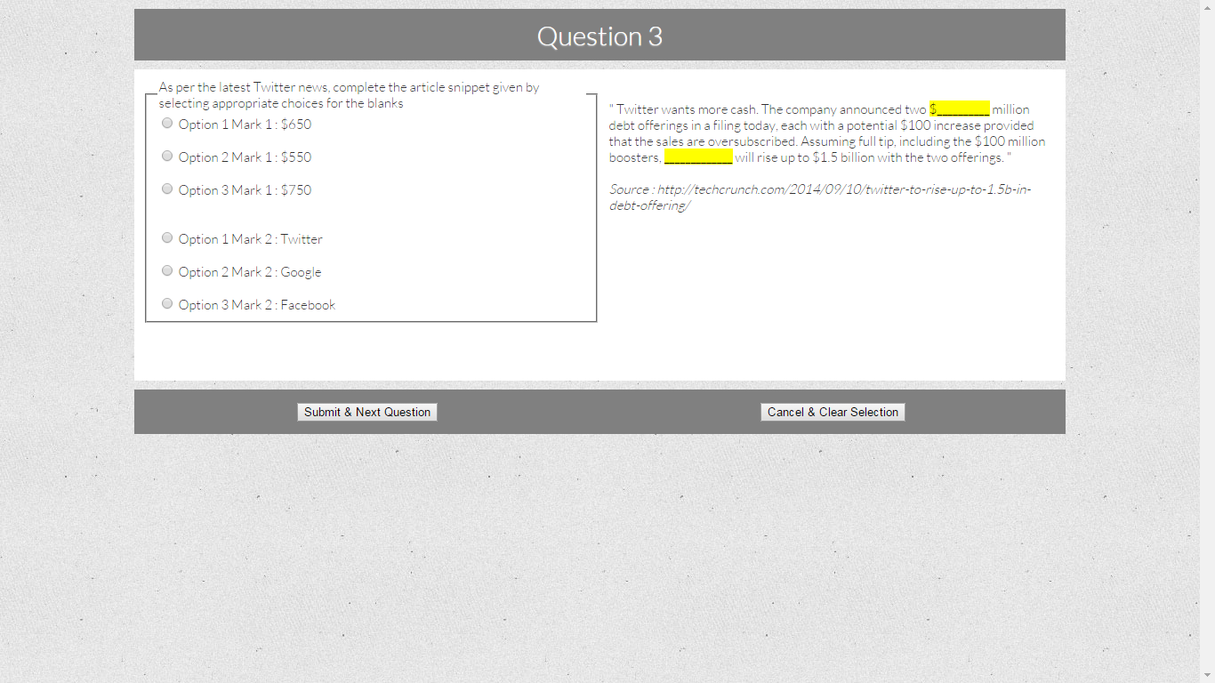

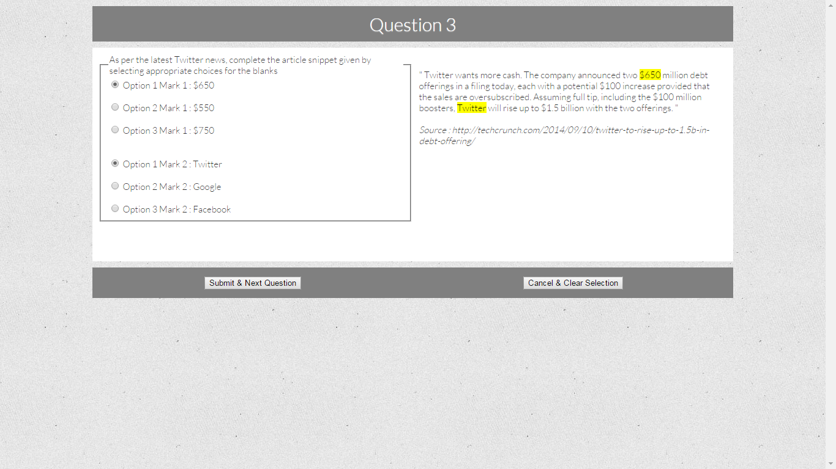

**5. Video Question screen**

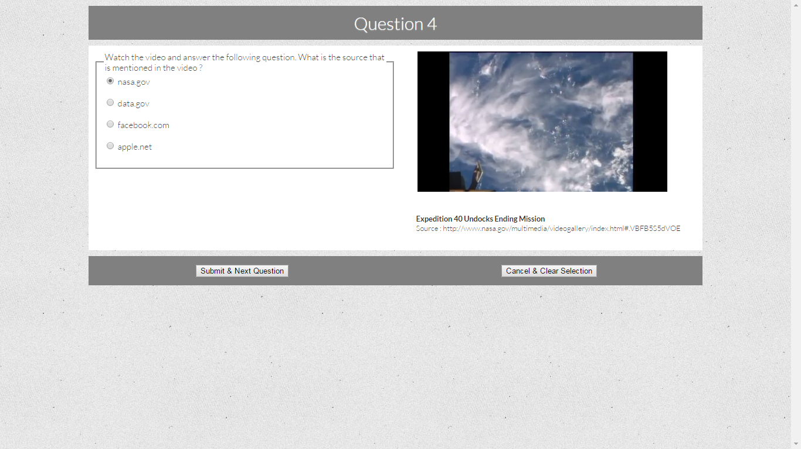

**6. Survey Screen**

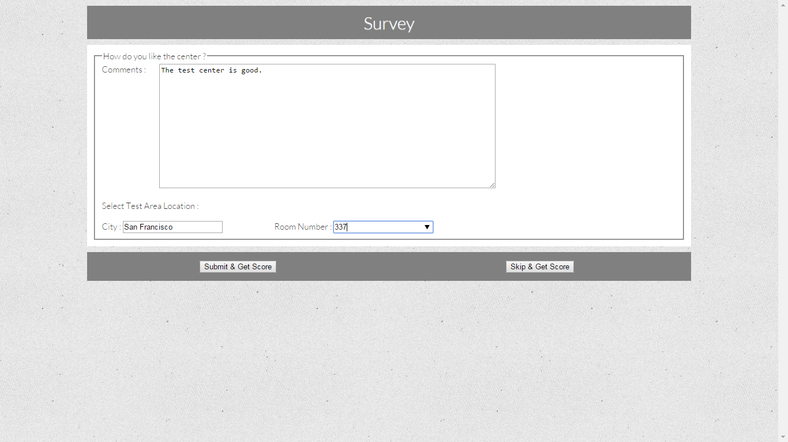

**7. Score Card screen**

